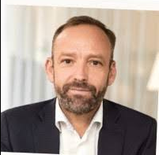

**CURRICULUM VITAE**

**Jakob Henningsen**

**Professional career**

1998-1999 Head of Section, The Danish Business Promotion Agency, Copenhagen

1999-2001 Head of Section, Ministry of Foreign Affairs, Copenhagen

2001-2004 First Secretary, Royal Danish Embassy Dar es Salaam

2004-2007 Head of Section, Ministry of Foreign Affairs, Copenhagen

2007-2011 Minister Counsellor, Royal Danish Embassy Ottawa

2011-2015 Deputy Permanent Representative, Danish Delegation to NATO, Brussels

2015-2019 Head of Security and Stabilization Department, Ministry of Foreign Affairs, Copenhagen

2019-2021 Chief Advisor Foreign Policy and National Security, Prime Minister’s Office, Copenhagen

2021-2022 Associate Partner, Navigate Public Affairs, Copenhagen

2022 - present Ambassador Extraordinary and Plenipotentiary of the Kingdom of Denmark to Russian Federation, Republic of Belarus, Republic of Kazakhstan, Kyrgyz Republic, Republic of Tajikistan, Republic of Uzbekistan, and Turkmenistan

**Education**

1995 Master of International Relations Theory, University of Warwick

1998 Master of Political Science, University of Aarhus

Knight of My Order of the Dannebrog

Married to Kirsten Holdt Henningsen, has two sons

Foreign languages: Danish, English

Born 26 November 1971, Viborg, Denmark